PSY310 Lab in Psychology

ORIENTATION DISCRIMINATION TASK

Tutorial -2

Jocelyn Best

AU2110380

Repository link-

Introduction

The Signal Detection Theory (SDT), is an adaptable framework that can be used in a variety of psychological contexts. SDT is used to differentiate between when there is a stimulus and the signal is perceived, and when there is no stimulus, also known as the noise in perceptual investigations. Yes/no tasks, in which the participant must say whether they detected a stimulus or not, are frequently used in SDT. The response from the participant is assessed using a criterion that is dependent on the value of a decision variable. The decision variable is higher when the participant says ‘yes’ as compared to when they say no.

These responses are further bifurcated into four parts-

1- If the signal is present and they accurately identify it (HIT)

2- If the signal is present and they fail to identify it (MISS)

3- If there is no signal present (only noise) and they don’t identify it (CORRECT REJECTION)

4- If there is no signal present (only noise) but they identify it (FALSE ALARMS)

We can see the same from the following attachment-

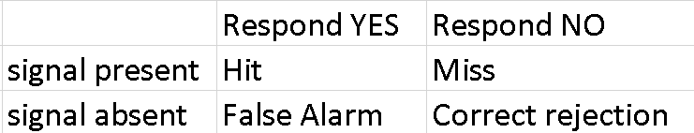

Method

Through this Orientation Discrimination task we tried to understand the kind of Bias the participant has in responding (C) There can be two kinds of biases, the liberal bias and the conservative bias as well as their sensitivity (d- prime) to the visual gratings.

The formula for the calculation of which is as follows:

d-prime = Z(prop hit) -Z(prop FA)

C= -Z(prop hit) + Z(prop FA)/2

Participants

There was only one participant in the experiment, who was the experimenter who created the experiment, as per the instructions for the assignment.

Material and procedure

This experiment was created using the PsychoPy application on the laptop and the steps mentioned below were used to create the experiment-

1. First, a Fixation cross was added in the shape of a triangle, which was scheduled to start and last for 1.0 seconds. The position for the fixation will be in the center (0,0)
2. Next, a grating will be added from the stimulus menu. This will start at 1.0 and last for 0.3 seconds. The orientation will be set to $Tilt, and change the option to ‘set every repeat’ from ‘constant’ in the layout tab. In the appearance tab, the contrast has to be set to 0.3, The mask will be set to ‘Gauss”. The spatial frequency will be set at 5.
3. The third step is to add a key response from the response menu, which will start at 1.0 and stay until the response is recorded. The allowed response key would be ‘up’ and ‘down’. In the data tab, we will tick on the store correct option, and in the correct answer box, we will add in $corrAns.
4. Finally, a code from the custom menu must be added, this code has to be added at the beginning of the experiment tab and in the end of the routine tab.
5. As for the last step, we will add a loop, with a loop type of random, and set the N reps to 300. (This was mentioned in the instructions)

Testing

The testing was done on the basis of 300 consecutive trials which had to be taken by the participant without any distractions.

The Data

The data from running the experiment is stored directly in Excel via Psychopy. Upon opening the data the experimenter cleaned the data, removing all the extraneous data which wasn’t needed. Only the key_resp.keys, key_resp.corr and the tilt columns were kept. The data was further bifurcated into HIT, MISSES, FALSE ALARM, and CORRECT REJECTIONS. Calculations were done on the following data to determine, The hit rate, False alarms, d-prime, and (C) that is sensitivity.

Hit rate was calculated via-

Prop hit = hit/hit+miss

False alarms was calculated via-

Prop FA = FA/FA+Correct rejection

Results

The results that were obtained through the experiment conducted on the participants provided us with the following data,

* The participant had 100 hits
* 68 misses
* 30 false alarms
* And 102 correct rejections.
* The d- prime of the participant was 0.9888
* The C that was obtained was -0.6149

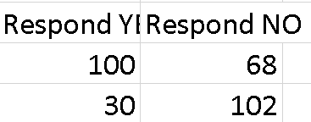

The chart for the categories.

Discussion

* Here bias refers to the participant's tendency to be more biased towards answering ‘Yes’ ‘No’
* Sensitivity is the ability of the participant to detect the signal and noise correctly.
* Through the results, we see that the participant was quite accurate in detecting the signals and hence had a higher hit rate as compared to the false alarm rate. The d-prime here is 0.9888
* The criterion obtained from the results was -0.6149 which means that the participant had a higher tendency to say ‘No’. The bias in play is the conservative bias.
* Overall, through the results we can see that the participant was accurate most of the time in detecting signal from noise.

|  |
| --- |
|  |